Answer Key for Chapter Review Homework #1-21.
Answer Keys for 10.3 and 10.4 Mini-Assessments and the 10.1-10.4 Quiz on page 435 are on the next pages (these are optional, extra practice if you choose to complete them.

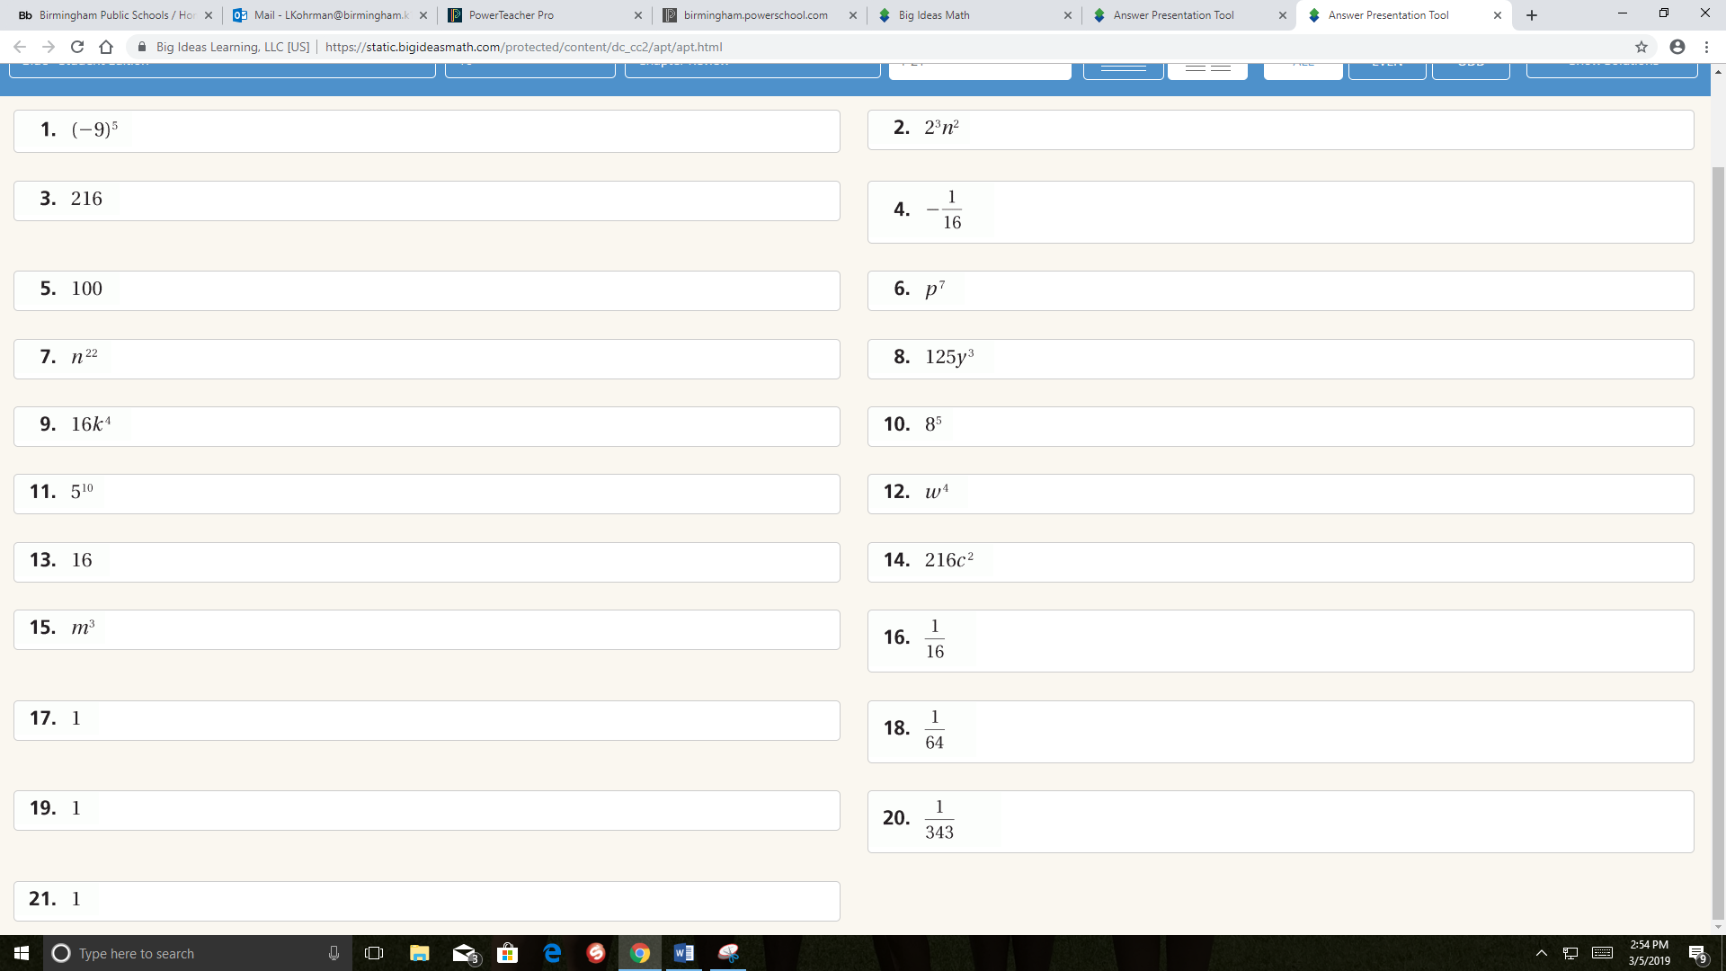
Answer Keys for 10.3 and 10.4 Mini-Assessments
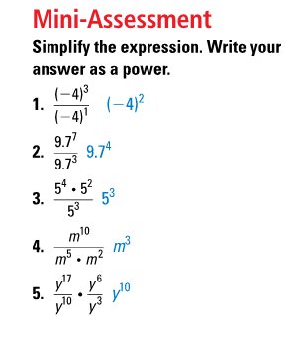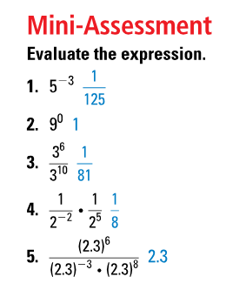

10.1-10.4 Quiz
