3.1 Practice

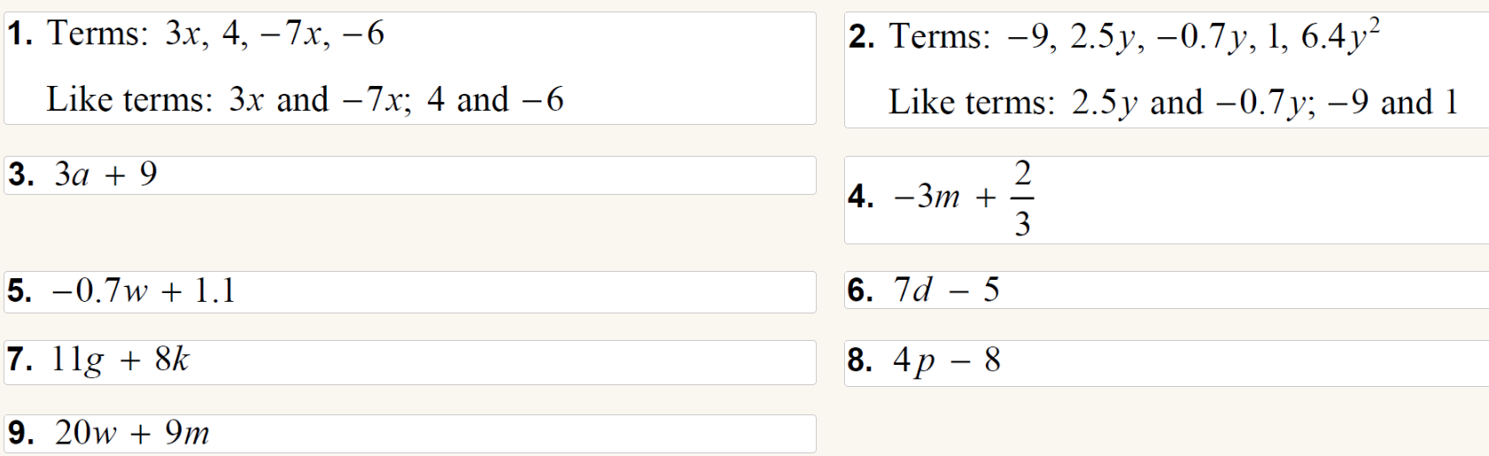

3.2 Practice

