Ch 1 Equation Practice
- W=-76
- M=18
- K=6
- X= -2pi
- D=5
- M= 1 11/40
- Y=2
- W=-1
- Y = 7/3 or 2 and 2 2/3
- N= -9
- X = 160 angles: 100, 80, 80, 135, 145

Pg 32 #1-10 and 15
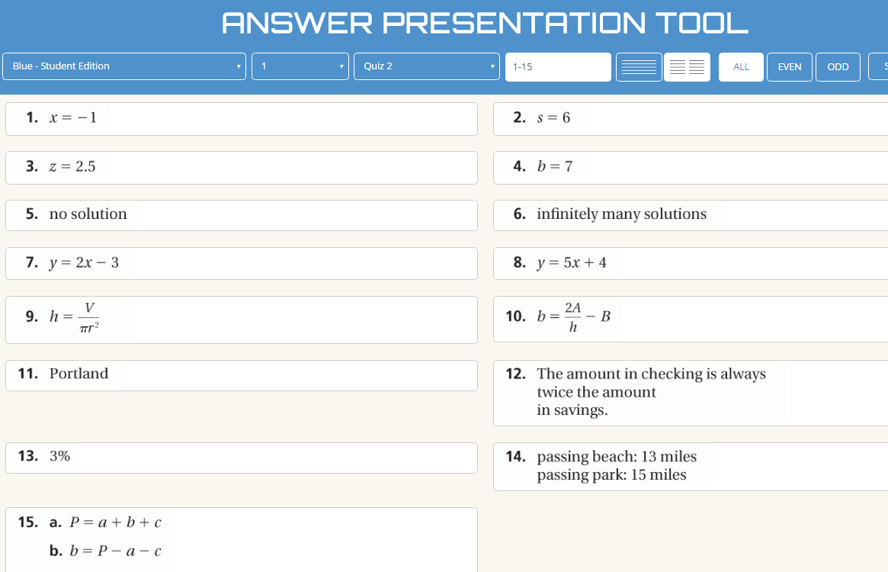

Pg 36 #10-15
