**Chapter Review Answer Key**

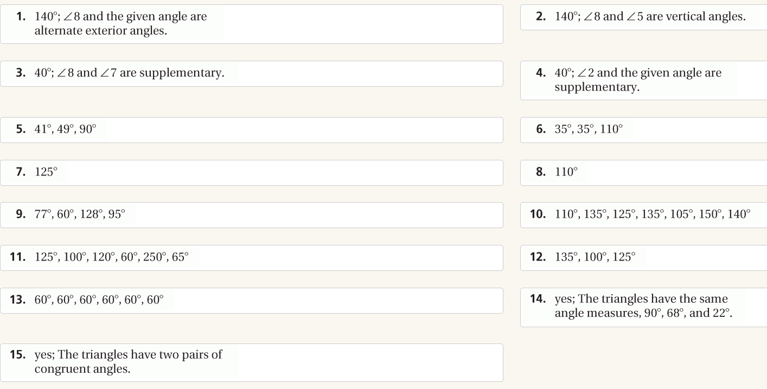

**Chapter Test Answer Key**

