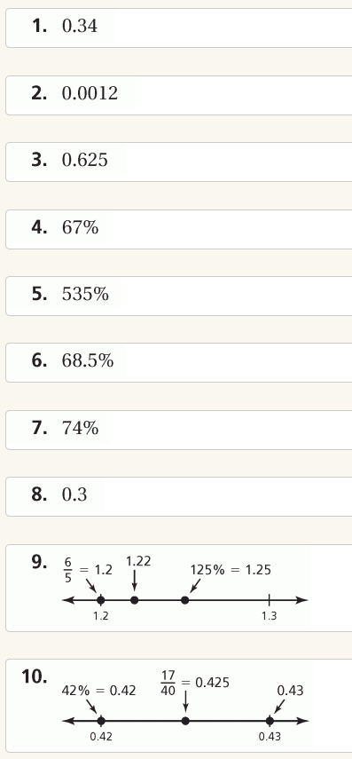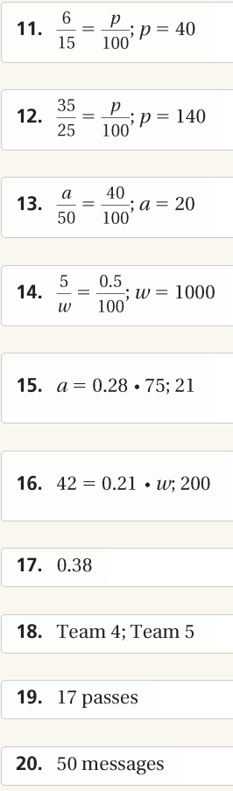
You Don’t have to graph the numbers on a number line – just list them from least to greatest.

